Water Dispenser

About 71% of earth is covered with water, but sadly only 2.5% of it is drinking water. With rise in population, pollution and climate change, it is expected that by as soon as 2025 we will experience perennial water shortages. At one hand there are already minor disputes among nations and states for sharing river water on the other hand we as humans waste a lot of drinking water due to our negligence.
It might not appear big at the first time, but if your tap dripped a drop of water once every second it would take only about five hours for you to waste one gallon of water, that is enough water for an average human to survive for two days. So what can be done to stop this? As always the answer, for this, lies with improvement in technology. If we replace all the manual taps with a smart one that opens and closes on its own automatically not only we can save water but also have a healthier lifestyle since we don’t have to operate the tap with our dirty hands. So in this project we will build a Automatic Water Dispenser using Arduino and a Solenoid valve that can automatically give you water when a glass is placed near it.

Materials Required
- Dc Water Pump
- Arduino Uno (any version)
- HCSR04 – Ultrasonic Sensor
- Covering Plastic.

Working Concept
The Concept behind the Automatic Water Dispenser is very simple. We will use a HCSR04 Ultrasonic Sensor to check if any object such that the glass is placed before the dispenser. A solenoid valve will be used to control the flow of water, which is when energised the water will flow out and when de-energised the water will be stopped. So we will write an Arduino program which always checks if any object is placed near the tap, if yes then the solenoid will be turned on and wait till the object is removed, once the object is removed the solenoid will turn off automatically thus closing the supply of water.

Arduino Uno:
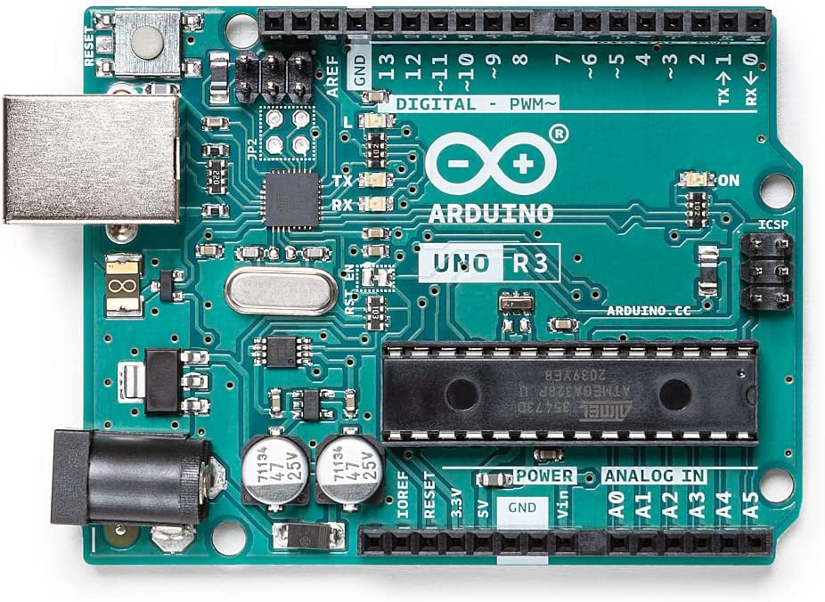

Arduino is an open-source platform used for building electronics projects. Arduino consists of both a physical programmable circuit board (often referred to as a microcontroller) and a piece of software, or IDE (Integrated Development Environment) that runs on your computer, used to write and upload computer code to the physical board.

Ultrasonic Sensor:

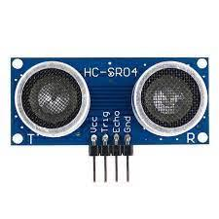
Ultrasonic sensors work by sending out a sound wave at a frequency above the range of human hearing. The transducer of the sensor acts as a microphone to receive and send the ultrasonic sound. Our ultrasonic sensors, like many others, use a single transducer to send a pulse and to receive the echo. The sensor determines the distance to a target by measuring time lapses between the sending and receiving of the ultrasonic pulse. Figure 2 shows the pin configuration for ultrasonic sensor module (HC-SRO4) which includes.

- Vcc (5 volt Supply )
- Trigger pin
- Echo pin
- Gnd (0volt)
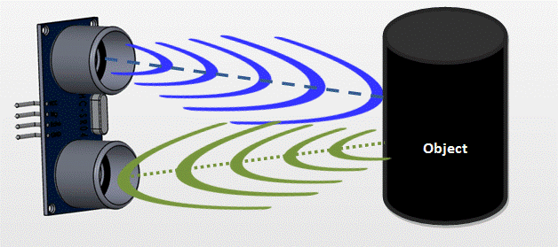

5VDC water Pump:
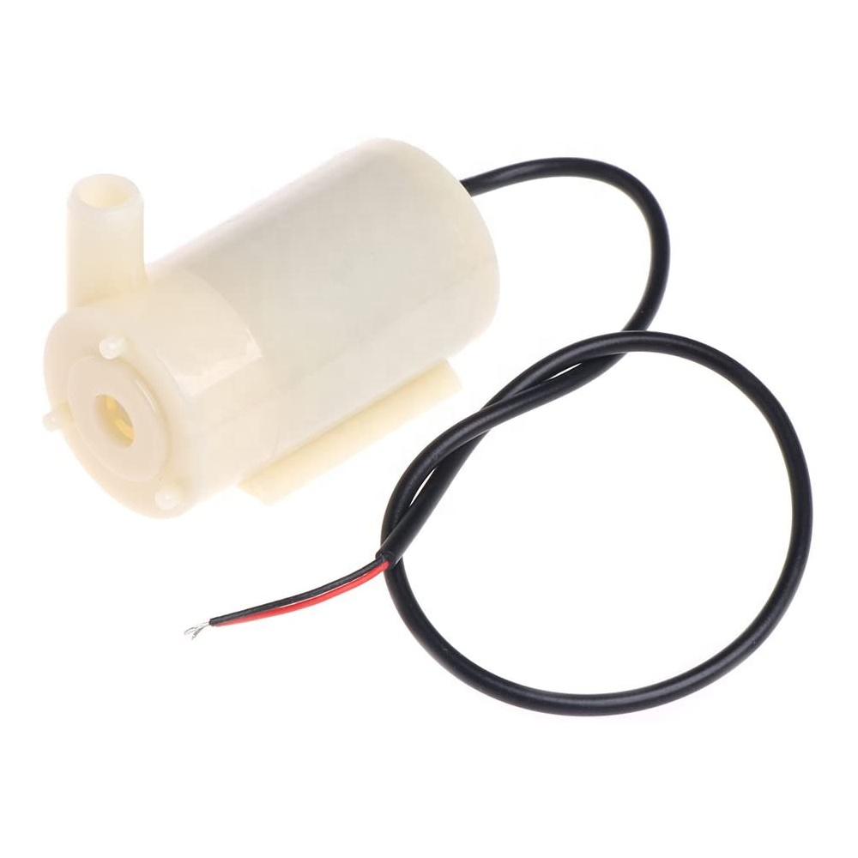
A High Performance non submersible dc water pump is a device which has a hermetically sealed motor close-coupled to the pump body. Some part of assembly is submerged in the fluid to be pumped. The main advantage of this type of pump is that it prevents pump cavitations a problem associated with a high elevation difference between pump and the fluid surface. Submersible pumps push fluid to the surface as opposed to jet pumps having to pull fluids.
This is a low cost, small size Submersible Pump Motor. It can take up to 120 liters per hour with very low current consumption of 220mA. Just connect tube pipe to the motor outlet, submerge it in water and power it.

Relay:
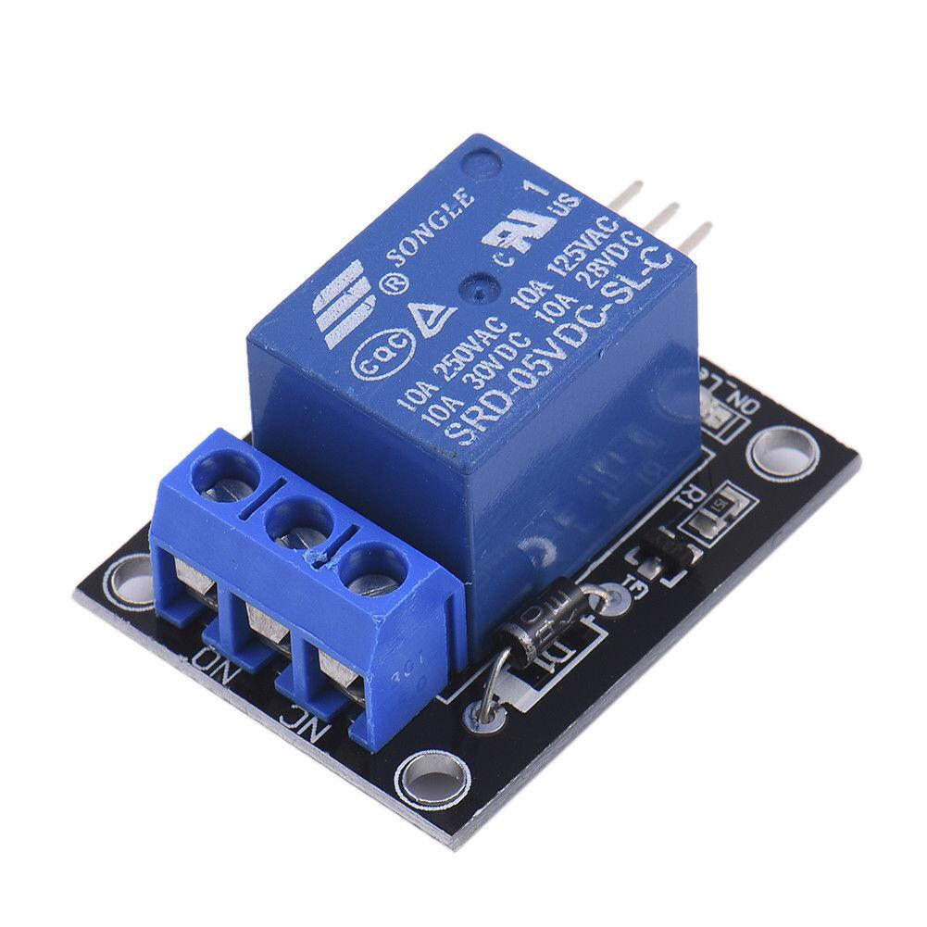
The Relay Module is a convenient board which can be used to control high voltage, high current load such as motor, solenoid valves, lamps and AC load. It is designed to interface with microcontroller such as Arduino, PIC and etc. The relays terminal (COM, NO and NC) is being brought out with screw terminal.

Circuit:
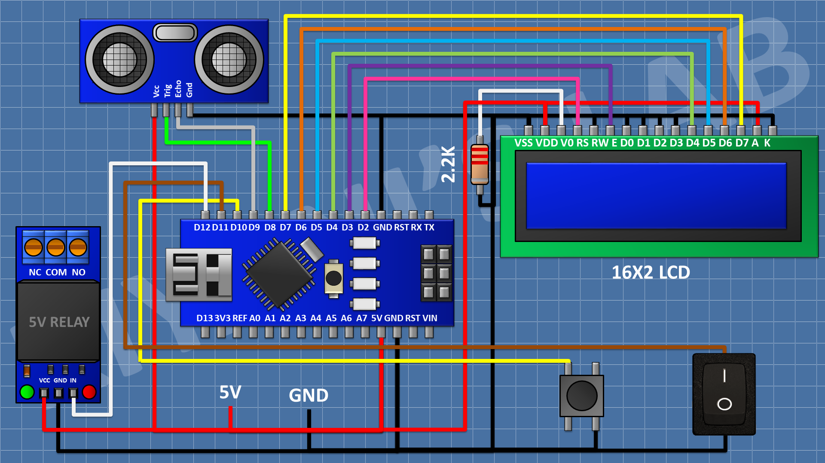

Code:
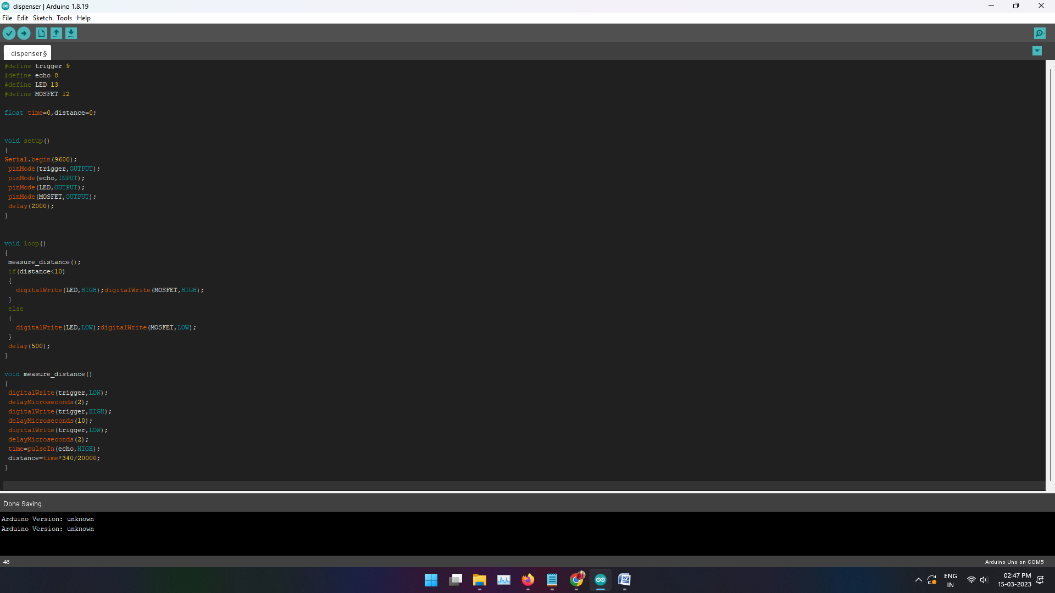

Conclusion:
Automatic water Dispenser system employs the use of different technologies in the whole design its
development and implementation. The system is used by the microcontroller to automatic the process of water which is used by human beings and it has the ability to detect the level of water, the TDS of water, the temperature of water, and the use of the LCD in this system provides the output which is very useful for human beings.

